🗓️ Day 14

📌📌What is Bug Life Cycle:

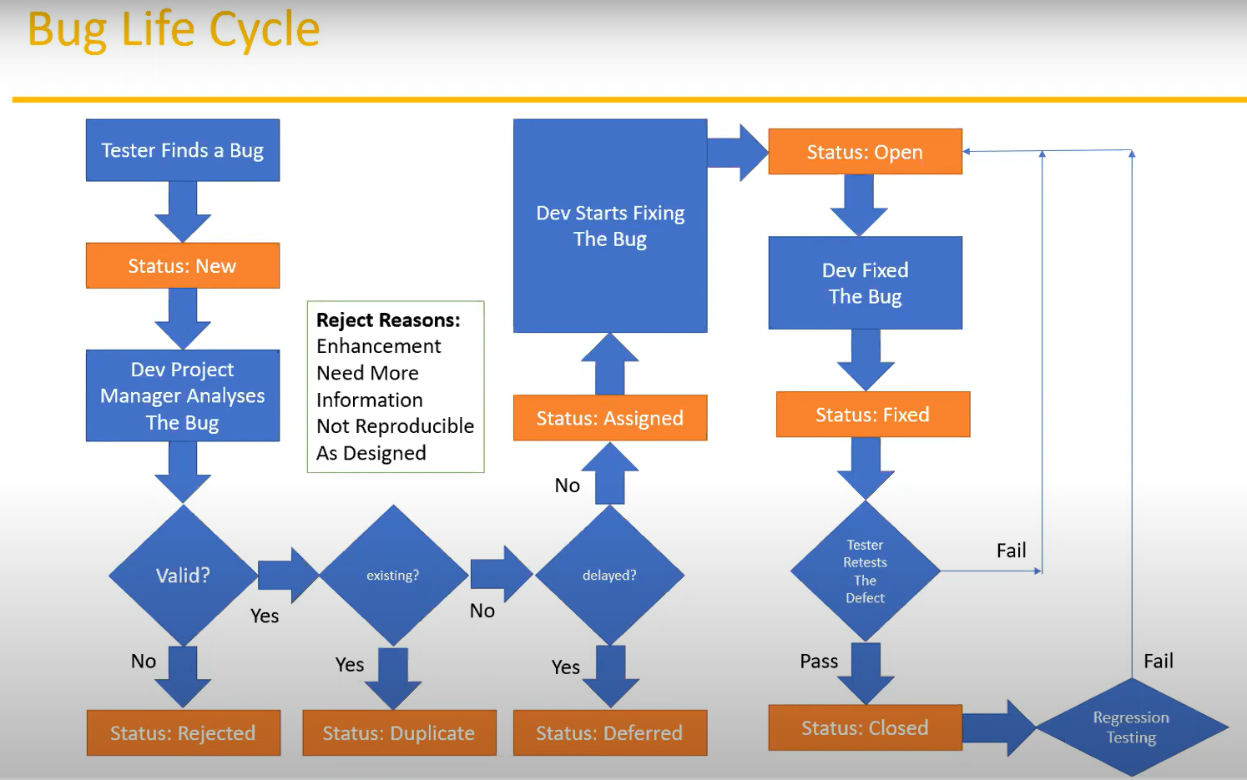

**1️⃣ Tester Finds a Bug**

* Status: **New**
* A bug is found and reported.

**2️⃣ Dev Project Manager Analyses The Bug**

* The project manager (or lead) checks the bug report.

**3️⃣ Check if Bug is Valid?**

* **No → Status: Rejected**
  + Reasons (shown in the diagram box):
    - Enhancement (not a bug but a new feature request)
    - Need More Information
    - Not Reproducible (can’t recreate the issue)
    - As Designed (behavior is as expected)
* **Yes → Move to next step**

**4️⃣ Check if Bug is Already Existing?**

* **Yes → Status: Duplicate**
  + The bug is already reported.
* **No → Move to next step**

**5️⃣ Check if Bug Fix is Delayed?**

* **Yes → Status: Deferred**
  + Fix postponed to a future release.
* **No → Status: Assigned**
  + Assigned to a developer to fix.

**6️⃣ Dev Starts Fixing the Bug**

* Status: **Open**
* Developer actively works on the bug.

**7️⃣ Dev Fixed The Bug**

* Status: **Fixed**
* Developer completes the fix.

**8️⃣ Tester Retests The Defect**

* **Pass → Status: Closed**
  + Bug is fixed and verified by the tester.
* **Fail → Goes back to "Dev Starts Fixing the Bug"**
  + Bug fix did not work, needs to be reopened and fixed again.

**9️⃣ Regression Testing**

* If the defect fix passes, regression testing is performed to ensure new changes didn’t break other parts of the system.
* If regression fails, the bug is reopened again.

📌📌Test Cycle Closure:

Activities:

Evaluate cycle completion criteria based on Time, Test coverage, Cost, Software, Critical Business Objectives, Quality

Prepare test metrics based on the above parameters.

Document the learning out of the project

Prepare Test summary report

Qualitative and quantitative reporting of quality of the work product to the customer.

Test result analysis to find out the defect distribution by type and severity.

Deliverables

Test Closure report

Test metrics

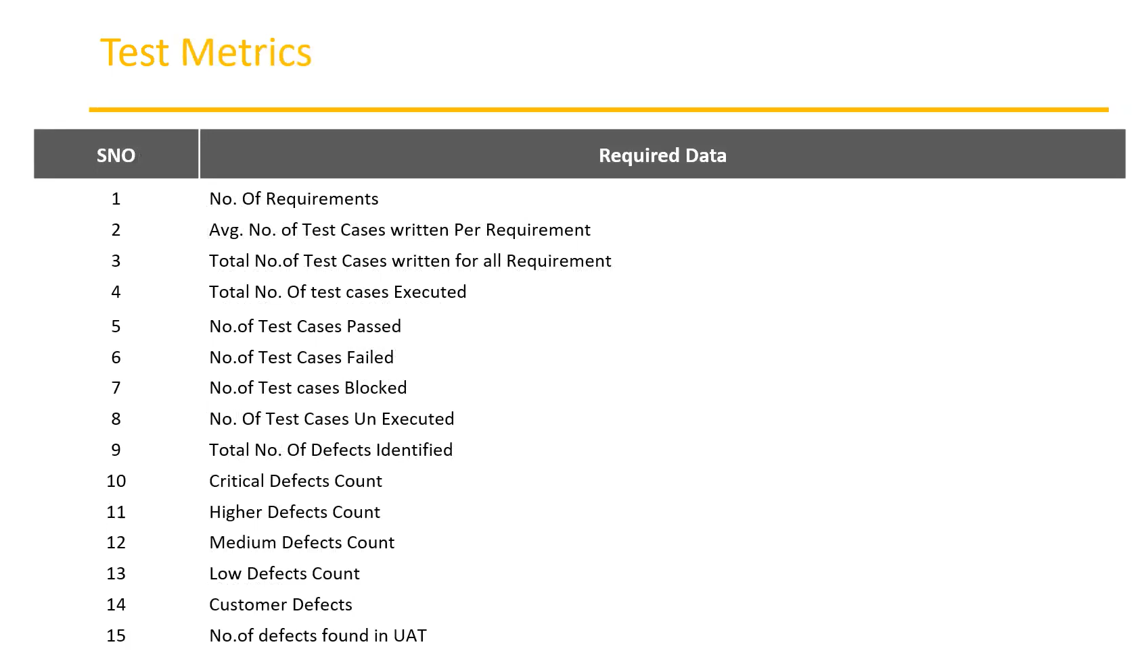

📌📌Test Metrics :

% of Test cases Executed:

No.of Test cases executed / Total No. of Test cases written) * 100

% of test cases NOT executed:

(No.of Test cases NOT executed/Total No. of Test cases written) * 100

% Test cases passed

(No.of Test cases Passed/Total Test cases executed) * 100

% Test cases failed

(No.of Test cases failed / Total Test cases executed) * 100

%Test cases blocked

(No.of test cases blocked / Total Test cases executed) * 100

Defect Density:

Number of defects identified per requirement/s

No.of defects found / Size(No. of requirements)

Defect Removal Efficiency (DRE):

(A/A+B) 100

(Fixed Defects/(Fixed Defects + Missed defects)) 100

A- Defects identified during testing/Fixed Defects

B-Defects identified by the customer/Missed defects

Defect Leakage:

(No.of defects found in UAT / No. of defects found in Testing) * 100

Defect Rejection Ratio:

(No. of defect rejected/Total No. of defects raised) * 100

Defect Age: Fixed date-Reported date

Customer satisfaction = No.of complaints per Period of time

📌📌QA/Testing Activities:

Understanding the requirements and functional specifications of the application.

Identifying required Test Scenario's.

Designing Test Cases to validate application.

Setting up Test Environment (Test Bed)

Execute Test Cases to valid application

Log Test results (How many test cases pass/fail).

Defect reporting and tracking.

Retest fixed defects of previous build

Perform various types of testing's in application.

Reports to Test Lead about the status of assigned tasks

Participated in regular team meetings.

Creating automation scripts.

Provides recommendation on whether or not the application/system is ready for production